Continuous Optimization Using Evolutionary Strategies

1. Introduction
In this project, an Evolutionary Strategy (ES) is applied to solve a continuous global optimization assignment based on the two dimensional Rastrigin function. The Rastrigin function is a classic benchmark for optimization algorithms, that it features a large number of local minima arranged in a grid-like pattern around a single global minimum at the origin, making it an ideal stress-test for methods that can easily become trapped by local search behavior [1, 2]. The goal of this project is not only to obtain a solution at or near the global optimum within the bounded domain (-5.12, 5.12)², but also to evaluate how key ES design choices; particularly the parent-to-offspring ratio (µ:λ), individual versus shared steps sizes (σ), and the use of recombination operators; affect solution quality, stability across different random seeds, and computational cost [3]. By conducting a structured set of 35 runs with progressively more sophisticated ES variants, we provided insight the exploration exploitation tradeoff in evolutionary strategies and quantifies which design choices provide the most reliable convergence toward the global minimum.

2. Methodology, Definitions and Assumptions

2.1. Problem definition
The optimization target is the two-dimensional Rastrigin function, defined as:

$$f\left(x_{1},x_{2}\right)=20+\left(x_{1}^{2}-10\cos\left(2πx_{1}\right)\right)+(x_{2}^{2}-10\cos\left(2πx_{2}\right))$$

Each variable is bounded to the range [-5.12, 5.12]. The function has a global minimum of f(0, 0) = 0.0 at the origin. The highly multimodal landscape, with approximately 50 local minima within the search domain, which makes this problem challenging for optimization.

2.2. Solution encoding
Each individual in the ES population is encoded as a real-valued vector x = (x₁, x₂) representing a candidate solution. Also, each individual carries one or more strategy parameters (σ) that control the mutation step size. Two encoding schemes are used across experiments: (1) Shared σ: A single standard deviation σ which is used for both variables; (2) Individual σ: Each variable has its own step size σ₁, σ₂, which allowing direction-dependent adaptation.

2.3. (µ, λ) ES selection
A comma strategy (µ, λ)-ES is adopted, where λ offspring are generated from µ parents each generation, and the best µ offspring are selected as the next generation’s parents. The comma strategy is preferred over the plus strategy for continuous optimization because, it allows the population to forget previously good but potentially misleading solutions. This improves exploration on multimodal landscapes like the Rastrigin function.

2.4. Mutation and the 1/5 success rule
Offspring are generated by adding Gaussian noise to parent solutions: x’ = x + σ · N(0, 1). In other words, the step size σ is adapted using Rechenberg’s 1/5 success rule: every 10 generations, the fraction of successful mutations is computed. If the success rate exceeds 1/5, then the σ is increased by dividing by a damping factor c = 0.82; if it falls below 1/5, so the σ is decreased by multiplying by c. Also, if exactly 1/5, σ remains unchanged. We thank that this self-adaptive mechanism allows the ES to balance exploration (large σ) and exploitation (small σ) throughout the search.

2.5. Recombination operators
In this step, two recombination operators are analyzed in the later experiments. (1) Global Intermediate Recombination (on σ): For each offspring, two random individuals are selected and their σ values are averaged to produce the offspring’s σ. This smooths step-size adaptation across the population. (2) Dual Discrete Recombination (on x): For each variable in the offspring, the value is randomly copied from one of two randomly selected individuals. This introduces diversity by mixing decision variables components.

2.6. Population initialization
The initial parent population consists of µ individuals drawn uniformly at random from the search domain [-5.12, 5.12]². The initial step size is set to σ₀ = 1. Five independent random seeds (1, 2, 3, 4, 5) are used to evaluate sensitivity to starting conditions and ensure reproducibility.

2.7. Stopping criterion
All runs uses a fixed stopping criterion of 500 generations. We think, this provides sufficient time for the ES to converge while keeping computational cost manageable.

2.8. Experimental design
To evaluate the progressive improvement of ES design choices in this assignment, five experiments are conducted. The detail is mentioned in the Table 1. Firstly, Experiment B tests three µ:λ ratios: (5, 35), (15, 100), and (30, 200), each run with 5 seeds = 15 runs. Secondly, The best ratio from Experiment B is then used for all subsequent experiments (C, D, E).

Table 1 Detail of the experiments (35 total runs across 5 ES variants)
Experiment | σ Encoding | σ Adaptation | Recombination | Runs
A: Basic ES | Single σ | 1/5 rule | None | 5
B: µ:λ sweep | Single σ | 1/5 rule | None | 15
C: Individual σ | Per-variable σ | 1/5 rule (each) | None | 5
D: σ Recomb | Per-variable σ | 1/5 rule + recomb | Global interned | 5
E: x Recomb | Per-variable σ | 1/5 rule | Dual discrete on x | 5

3. Results and Discussion

3.1. Rastrigin function visualization
Figure 1 shows the 3D surface and contour plot of the 2D Rastrigin function. The function’s highly multimodal nature is clearly visible in both plots, with numerous regularly spaced local minima surrounding the global minimum at the origin.
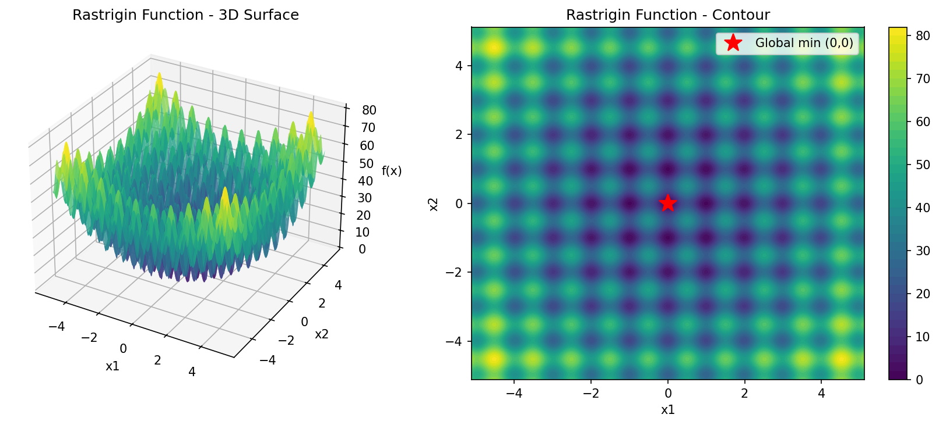
Figure 1 Rastrigin function, 3D surface and contour plot

3.2. Single run performance
The initial single run of the (µ, λ) for ES was executed with µ=15 parents, λ=100 offspring, a single shared σ (initial σ₀ = 1.0), the 1/5 success rule, and no recombination over 500 generations using seed 42. So, the ES produced a best cost of approximately 0.0 (f ≈ 7.9×10⁻¹⁰) at x* ≈ (1.4×10⁻⁶, -1.4×10⁻⁶), which effectively reaching the global optimum. Figure 2 and Figure 3 shows the results for the single run.
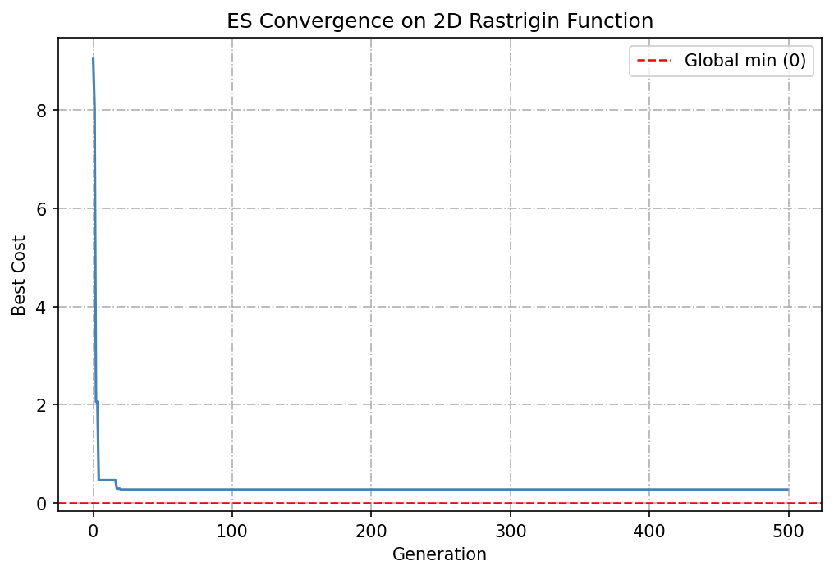
Figure 2 Single run convergence curve over 500 generations
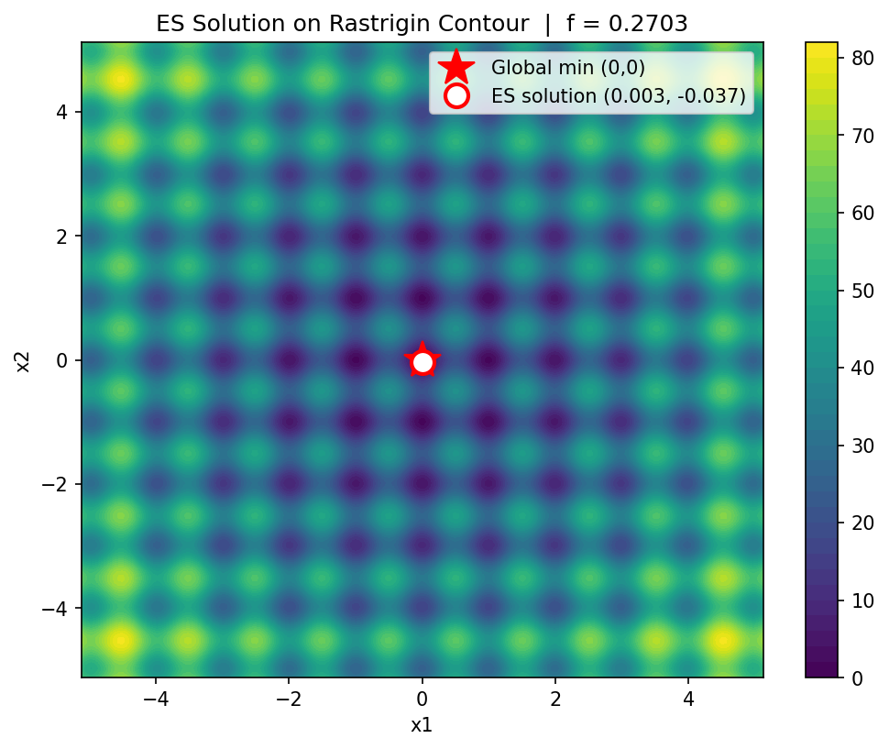
Figure 3 ES solution on the Rastrigin contour plot

3.3. Experiment A: basic ES
The basic ES was run with 5 different seeds using µ=15, λ=100. Four of the five seeds found solutions extremely close to the global optimume (f < 10⁻⁹), while seed 3 converged to a local minimum with f ≈ 0.2269. The mean cost across all 5 runs was 0.0454 with a standard deviation of 0.1015. The results are in the Table 2.

Table 2 Experiment A results, Basic ES with 5 seeds
Seed | Best x₁ | Best x₂ | Best Cost | Runtime (s)
1 | 1.40E-06 | -1.43E-06 | 7.91E-10 | 0.149
2 | 1.82E-06 | 1.07E-06 | 8.83E-10 | 0.136
3 | 2.58E-02 | -2.19E-02 | 2.27E-01 | 0.135
4 | -5.37E-07 | 7.33E-07 | 1.64E-10 | 0.136
5 | -3.99E-08 | 2.01E-06 | 8.04E-10 | 0.133

3.4. Experiment B: µ:λ ratio sweep
Three µ:λ ratios were tested: (5, 35), (15, 100), and (30, 200). The ratio 30:200 consistently outperformed the other two configurations, that achieving near-zero cost on all 5 seeds. The 5:35 ratio showed the highest mean cost and greatest variance. Table 3 and Figure 4 shows the detail of each seed. Figure 4 uses a logarithmic scale to highlight the orders of magnitude difference between ratios; which the 30:200 ratio achieved costs around 10⁻¹⁰, while the 5:35 and 15:100 ratios had outliers near 10⁻¹ (local minima traps).

Table 3 Mean cost by µ:λ ratio across 5 seeds
µ:λ Ratio | Mean Cost | Std | Min Cost | Max Cost
5:35 | 6.24E-02 | 8.77E-02 | 2.20E-09 | 2.12E-01
15:100 | 4.54E-02 | 1.01E-01 | 1.64E-10 | 2.27E-01
30:200 | 1.50E-10 | 9.48E-11 | 5.92E-11 | 2.84E-10

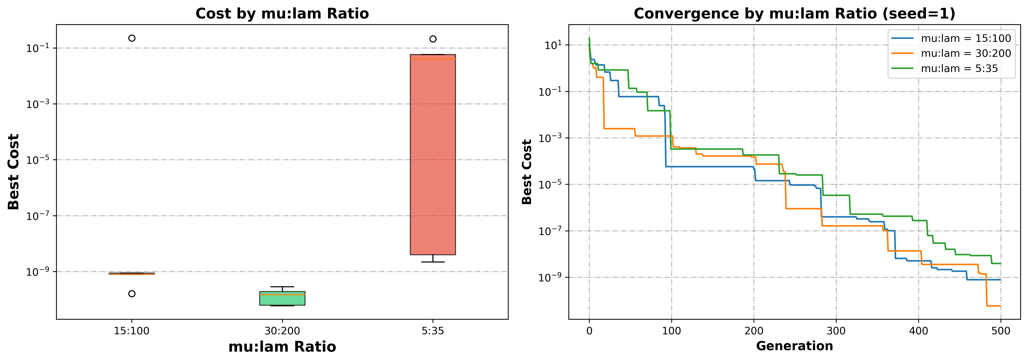
Figure 4 µ:λ ratio analysis — boxplot and convergence comparison

Based on these results, the best µ:λ ratio of 30:200 was selected for all subsequent experiments. The full results of the 15 runs are shown in the Table 4.

Table 4 Results of the experiment B (15 runs)
Run id | seed | µ | λ | µ:λ ratio | Best x₁ | Best x₂ | Best cost | Runtime (s)
6 | 1 | 5 | 35 | 5:35 | 4.43E-06 | 5.89E-07 | 3.96E-09 | 0.053
7 | 2 | 5 | 35 | 5:35 | 0.012653 | 0.011538 | 0.058149 | 0.055
8 | 3 | 5 | 35 | 5:35 | -0.0091 | -0.03149 | 0.212475 | 0.055
9 | 4 | 5 | 35 | 5:35 | 3.09E-06 | 1.25E-06 | 2.2E-09 | 0.053
10 | 5 | 5 | 35 | 5:35 | -0.0143 | -0.00203 | 0.041357 | 0.052
11 | 1 | 15 | 100 | 15:100 | 1.4E-06 | -1.4E-06 | 7.91E-10 | 0.137
12 | 2 | 15 | 100 | 15:100 | 1.82E-06 | 1.07E-06 | 8.83E-10 | 0.137
13 | 3 | 15 | 100 | 15:100 | 0.025795 | -0.02192 | 0.226909 | 0.140
14 | 4 | 15 | 100 | 15:100 | -5.4E-07 | 7.33E-07 | 1.64E-10 | 0.133
15 | 5 | 15 | 100 | 15:100 | -4E-08 | 2.01E-06 | 8.04E-10 | 0.131
16 | 1 | 30 | 200 | 30:200 | 1.4E-07 | 5.28E-07 | 5.92E-11 | 0.250
17 | 2 | 30 | 200 | 30:200 | -5E-07 | -2.5E-07 | 6.21E-11 | 0.258
18 | 3 | 30 | 200 | 30:200 | -1.1E-06 | 5.26E-07 | 2.84E-10 | 0.252
19 | 4 | 30 | 200 | 30:200 | -5.1E-08 | -9.9E-07 | 1.94E-10 | 0.251
20 | 5 | 30 | 200 | 30:200 | 8.66E-07 | 4.64E-08 | 1.49E-10 | 0.252

3.5. Experiment C: Individual σ per variable
Using the best ratio (30:200), individual step sizes σ₁ and σ₂ were assigned to each variable, each adapted independently via the 1/5 success rule. All 5 seeds converged to the global optimum with mean cost 1.4975e-10 and standard deviation 9.4752e-11 (Table 5). For a two-variable problem, the benefit of individual σ is limited since the landscape is symmetric in x₁ and x₂, but this variant provides the foundation for the recombination experiments that follow.

Table 5 Results of the experiment C (5 runs)
Run id | seed | Best x₁ | Best x₂ | Best cost | Runtime (s)
21 | 1 | 1.40206E-07 | 5.28067E-07 | 5.92237E-11 | 0.240
22 | 2 | -5.01135E-07 | -2.48807E-07 | 6.2105E-11 | 0.237
23 | 3 | -1.0749E-06 | 5.26389E-07 | 2.84196E-10 | 0.239
24 | 4 | -5.08489E-08 | -9.87593E-07 | 1.94014E-10 | 0.238
25 | 5 | 8.66055E-07 | 4.63572E-08 | 1.49232E-10 | 0.240

3.6. Experiment D: Global intermediate recombination on σ
Building on Experiment C, then global intermediate recombination was applied to the step sizes: for each offspring, σ is set to the average of two randomly selected parents’ σ values. The 1/5 rule is applied first, and then recombination is performed. So, all 5 seeds converged to the global optimum with mean cost 2.4462e-10 (Table 6). The best run across all 35 experiments came from this variant (seed 5, f* = 1.8122e-11). The mean runtime increased to 0.668s due to the additional recombination computation.

Table 6 Results of the experiment D (5 runs)
Run id | seed | Best x₁ | Best x₂ | Best cost | Runtime (s)
26 | 1 | -8.8E-07 | -1.4E-06 | 5.25E-10 | 0.667
27 | 2 | 5.14E-07 | 3.31E-07 | 7.43E-11 | 0.665
28 | 3 | -8.1E-07 | 7.15E-07 | 2.32E-10 | 0.650
29 | 4 | -6.8E-07 | -1.2E-06 | 3.74E-10 | 0.673
30 | 5 | -2.5E-08 | 3.01E-07 | 1.81E-11 | 0.724

3.7. Experiment E: Dual discrete recombination on x
In this final variant, dual discrete recombination is applied to the decision variables x₁ and x₂. So, Individual σ from Experiment C is retained (without σ recombination). Then, the next generation is created first using the standard mutation approach, and then recombination is applied. All 5 seeds converged to the global optimum with mean cost 3.8439e-10 and standard deviation 3.7113e-10 (Table 7). The mean runtime was 0.833s.

Table 7 Results of the experiment E (5 runs)
Run id | Best x₁ | Best x₂ | Best x₁ | Best x₂
31 | 8.31395E-07 | 7.91409E-07 | 2.61E-10 | 0.986
32 | 3.66097E-07 | -1.81644E-07 | 3.31E-11 | 0.829
33 | -5.75402E-07 | -1.1176E-07 | 6.82E-11 | 0.835
34 | 1.94662E-06 | 3.57714E-07 | 7.77E-10 | 0.815
35 | -1.82304E-06 | -7.86558E-07 | 7.82E-10 | 0.828

3.8. Comparison across all experiments
Figure 5 presents boxplots comparing the best cost achieved by each ES variant. So, Experiments A and B show rare outliers where the ES became trapped in local minima, while Experiments C, D, and E consistently achieved costs below 10⁻⁹. Also, The logarithmic scale in shows that Experiments C, D, and E achieved costs approximately 8 orders of magnitude lower than the outliers in A and B.
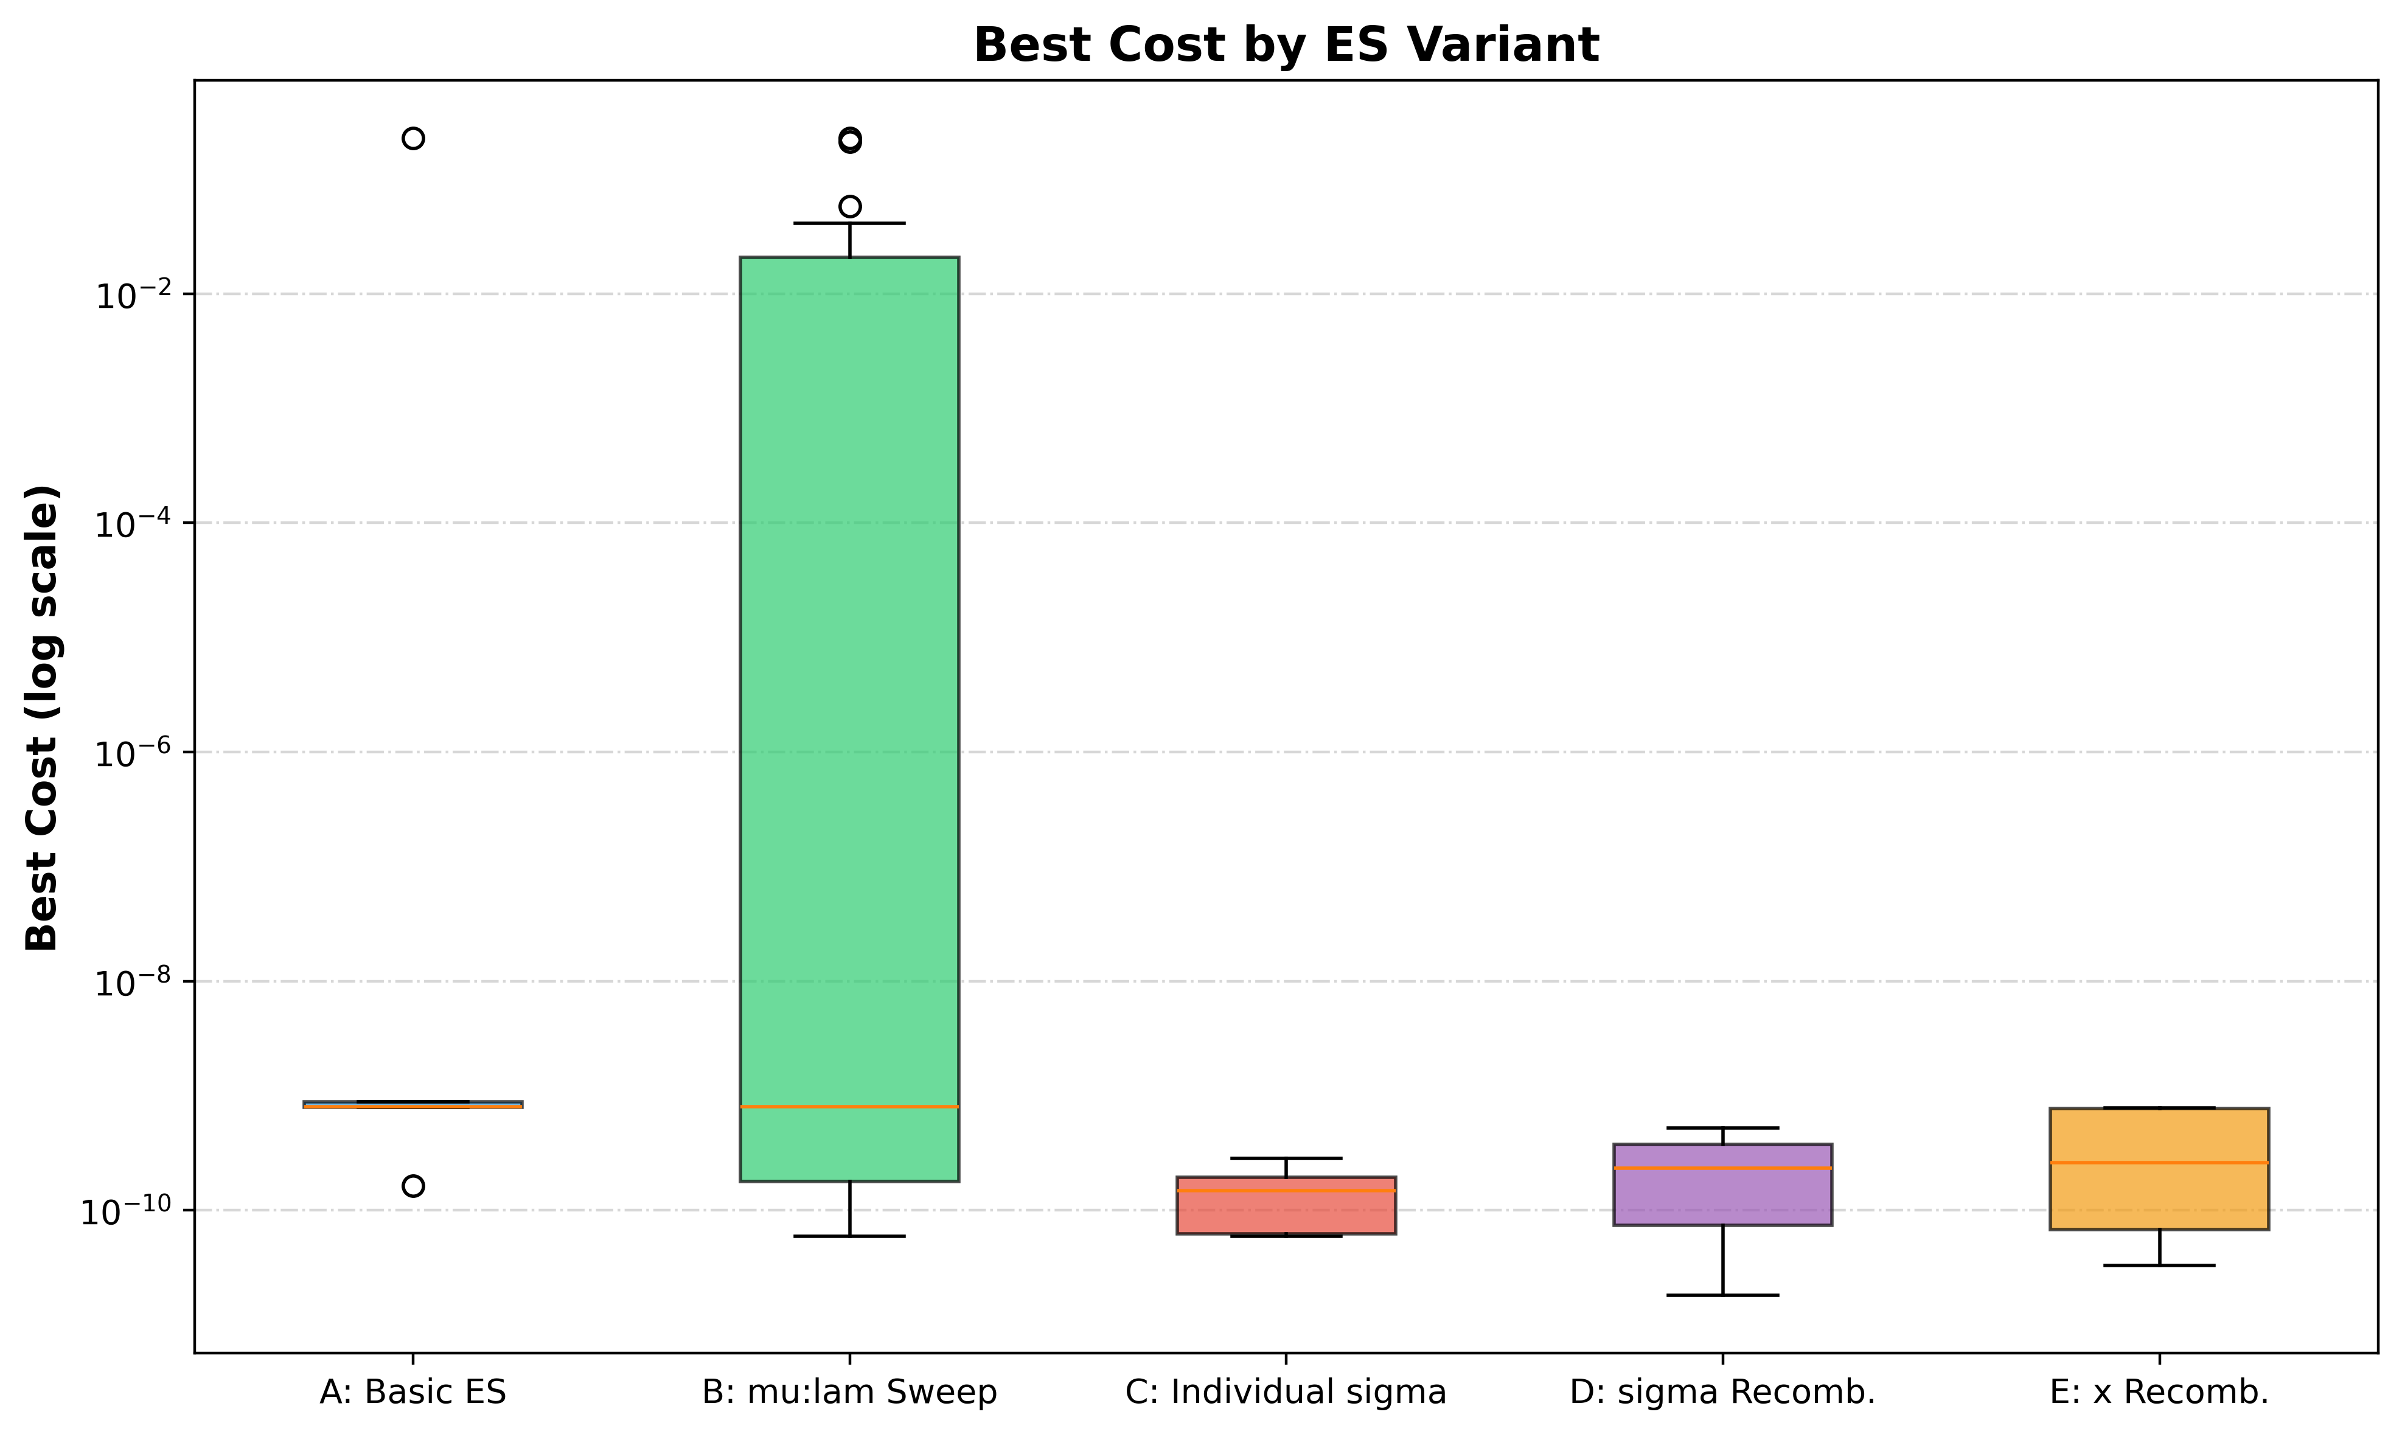
Figure 5 Best cost by ES variant

3.9. Convergence analysis
Figure 6 shows the convergence curves for all 35 runs grouped by experiment on a logarithmic scale. In other words, all variants exhibit rapid initial improvement in the first 50–100 generations. This dropping from ~10¹ to below 10⁻¹. In Experiment A, seed 3 plateaus near 10⁻¹, which indicats entrapment in a local minimum, while the other four seeds converge to ~10⁻⁹. Experiment B shows a similar pattern, that the smaller ratios (5:35, 15:100) have seeds that stagnate; whereas the 30:200 ratio converges reliably. Also, Experiments C, D, and E (all using 30:200) display remarkably consistent convergence across all seeds, which reaching 10⁻⁹ to 10⁻¹⁰ by generation 500. The staircase pattern visible in the log scale curves reflects the periodic σ adaptation by the 1/5 rule every 10 generations.
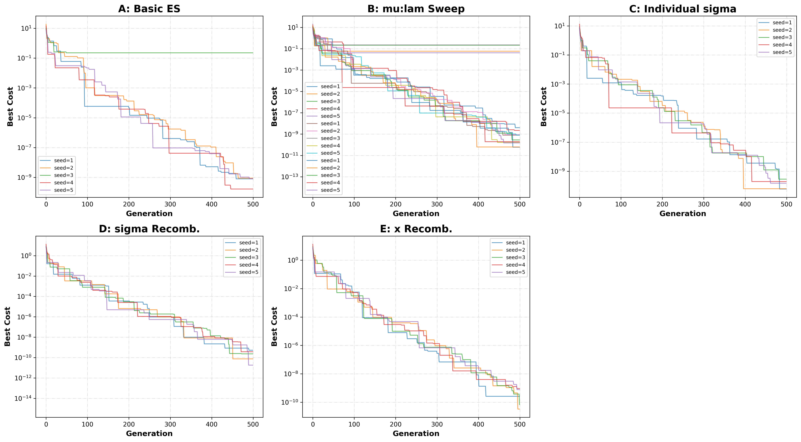
Figure 6 Convergence curves for all ES variants

3. 10. Best Solution across all 35 runs
The best solution across all 35 runs was found in Experiment D_sigma_recomb with seed 5, using µ:λ = 30:200. The solution is x* = (-0.00000002, 0.00000030) with f(x*) = 1.8122e-11, effectively the global optimum.
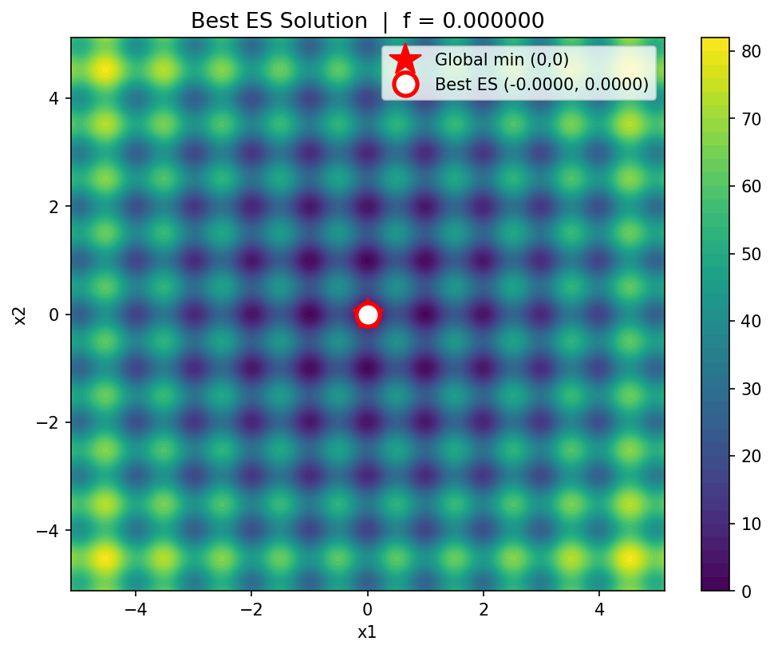
Figure 7 Best overall ES solution on the Rastrigin contour

3. 11. Runtime vs. cost tradeoff and summary of experiments
Figure 8 shows the runtime versus cost tradeoff. The basic ES and ratio sweep (A, B) complete fastest (mean 0.146s) but show greater cost variance. Also, experiment with recombination (D, E) take longer (mean 0.751s) but achieve consistently near-zero cost. So, the log scale shows that the cost difference between trapped and successful runs spans roughly 8 orders of magnitude (10⁻² vs. 10⁻¹⁰), which underscoring the importance of sufficient population size.

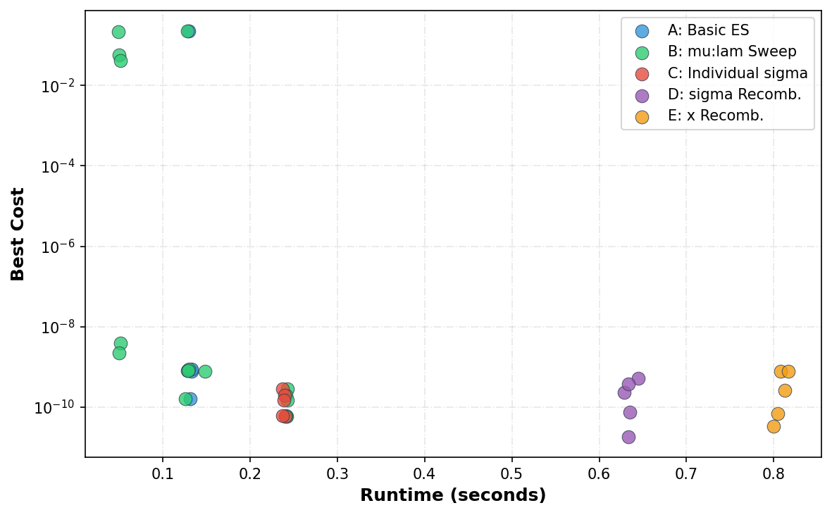
Figure 8 Runtime vs. best cost across all 35 runs

Table 1consolidates the performance of all five ES variants across the 35 runs. Experiments A and B, which use a single shared σ, exhibit mean costs on the order of 10⁻², driven by occasional seeds that become trapped in local minima (max cost ≈ 0.227). In contrast, Experiments C, D, and E; all of them using the 30:200 ratio with individual σ, which achieve mean costs on the order of 10⁻¹⁰, with negligible standard deviations. This confirming that every seed reliably converges to the global optimum. The best single run belongs to Experiment D (σ recombination), which reached f* = 1.81×10⁻¹¹. So, the runtime increases progressively from 0.131s (A) to 0.808s (E) as more complicated operators are added. but even the most expensive variant completes in under one second, it make the computational overhead of recombination negligible relative to improvement.

Table 8 Summary of all 35 ES runs
Experiment | Num Runs | Mean Cost | Std | Min Cost | Max Cost | Mean Runtime (s)
A: Basic ES | 5 | 0.045381891 | 0.101476991 | 1.64E-10 | 0.226909451 | 0.131
B: µ:λ sweep | 15 | 0.035926013 | 0.076702153 | 5.92E-11 | 0.226909451 | 0.142
C: Individual sigma | 5 | 1.50E-10 | 9.48E-11 | 5.92E-11 | 2.84E-10 | 0.239
D: sigma Recomb | 5 | 2.45E-10 | 2.10E-10 | 1.81E-11 | 5.25E-10 | 0.635
E: x Recomb | 5 | 3.84E-10 | 3.71E-10 | 3.31E-11 | 7.82E-10 | 0.808

4. Conclusion
This project applied a Evolutionary Strategy to minimize the two-dimensional Rastrigin function, which conducting 35 systematic runs across five progressively more sophisticated ES variants. The ES successfully found that the global optimum f(0, 0) = 0 in the majority of runs, with the best result achieving f* = 1.8122e-11 at x* ≈ (0, 0). Also, the key findings are: (1) The µ:λ ratio is the single most influential parameter. The 30:200 ratio consistently outperformed smaller ratios. (2) The 1/5 success rule provided effectively step-size adaptation without manual σ tuning. (3) Individual σ per variable provided consistent improvement by allowing direction-specific adaptation. (4) Global intermediate recombination on σ can produced the overall best solution. (5) Dual discrete recombination on x maintained reliable convergence.
Overall, the results validate the (µ, λ)-ES with the 1/5 success rule as an effective method for continuous multimodal optimization.

5. Python code
The Python codes used for this project are shared in GoogleColab, which is an online, free-access, and reproducible platform, as follows:

Jupyter notebook Evolutionary Strategies.ipynb

Also, I created a GitHub repository to publish this report and codes publicly available for anyone interested to use.

GitHub

References

- Schönenberger, L., & Beyer, H. G. (2023, July). On a population sizing model for evolution strategies optimizing the highly multimodal rastrigin function. In Proceedings of the Genetic and Evolutionary Computation Conference (pp. 848-855).
- Kauf, P. (n.d.). Introduction to evolutionary strategies. Kaggle. https://www.kaggle.com/code/pawelkauf/introduction-to-evolutionary-strategies
- Ha, D. (2017, October 29). A visual guide to evolution strategies. 大トロ. https://blog.otoro.net/2017/10/29/visual-evolution-strategies/

Appendix

Table A1: All 35 ES runs detailed results
Run | Experiment | Seed | µ:λ | Best x₁ | Best x₂ | Best Cost | RT (s)
1 | A_basic | 1 | 15:100 | 1.3987e-06 | -1.4252e-06 | 7.9111e-10 | 0.149
2 | A_basic | 2 | 15:100 | 1.8180e-06 | 1.0706e-06 | 8.8313e-10 | 0.136
3 | A_basic | 3 | 15:100 | 2.5795e-02 | -2.1922e-02 | 2.2691e-01 | 0.135
4 | A_basic | 4 | 15:100 | -5.3746e-07 | 7.3345e-07 | 1.6404e-10 | 0.136
5 | A_basic | 5 | 15:100 | -3.9903e-08 | 2.0127e-06 | 8.0399e-10 | 0.133
6 | B_ratio | 1 | 5:35 | 4.4304e-06 | 5.8950e-07 | 3.9630e-09 | 0.089
7 | B_ratio | 2 | 5:35 | 1.2653e-02 | 1.1538e-02 | 5.8149e-02 | 0.050
8 | B_ratio | 3 | 5:35 | -9.0964e-03 | -3.1488e-02 | 2.1248e-01 | 0.050
9 | B_ratio | 4 | 5:35 | 3.0909e-06 | 1.2465e-06 | 2.2037e-09 | 0.055
10 | B_ratio | 5 | 5:35 | -1.4300e-02 | -2.0271e-03 | 4.1357e-02 | 0.052
11 | B_ratio | 1 | 15:100 | 1.3987e-06 | -1.4252e-06 | 7.9111e-10 | 0.129
12 | B_ratio | 2 | 15:100 | 1.8180e-06 | 1.0706e-06 | 8.8313e-10 | 0.135
13 | B_ratio | 3 | 15:100 | 2.5795e-02 | -2.1922e-02 | 2.2691e-01 | 0.131
14 | B_ratio | 4 | 15:100 | -5.3746e-07 | 7.3345e-07 | 1.6404e-10 | 0.135
15 | B_ratio | 5 | 15:100 | -3.9903e-08 | 2.0127e-06 | 8.0399e-10 | 0.133
16 | B_ratio | 1 | 30:200 | 1.4021e-07 | 5.2807e-07 | 5.9224e-11 | 0.257
17 | B_ratio | 2 | 30:200 | -5.0113e-07 | -2.4881e-07 | 6.2105e-11 | 0.258
18 | B_ratio | 3 | 30:200 | -1.0749e-06 | 5.2639e-07 | 2.8420e-10 | 0.253
19 | B_ratio | 4 | 30:200 | -5.0849e-08 | -9.8759e-07 | 1.9401e-10 | 0.252
20 | B_ratio | 5 | 30:200 | 8.6606e-07 | 4.6357e-08 | 1.4923e-10 | 0.255
21 | C_indiv_sigma | 1 | 30:200 | 1.4021e-07 | 5.2807e-07 | 5.9224e-11 | 0.271
22 | C_indiv_sigma | 2 | 30:200 | -5.0113e-07 | -2.4881e-07 | 6.2105e-11 | 0.245
23 | C_indiv_sigma | 3 | 30:200 | -1.0749e-06 | 5.2639e-07 | 2.8420e-10 | 0.248
24 | C_indiv_sigma | 4 | 30:200 | -5.0849e-08 | -9.8759e-07 | 1.9401e-10 | 0.247
25 | C_indiv_sigma | 5 | 30:200 | 8.6606e-07 | 4.6357e-08 | 1.4923e-10 | 0.246
26 | D_sigma_recomb | 1 | 30:200 | -8.7803e-07 | -1.3688e-06 | 5.2467e-10 | 0.701
27 | D_sigma_recomb | 2 | 30:200 | 5.1446e-07 | 3.3120e-07 | 7.4273e-11 | 0.657
28 | D_sigma_recomb | 3 | 30:200 | -8.1218e-07 | 7.1491e-07 | 2.3226e-10 | 0.658
29 | D_sigma_recomb | 4 | 30:200 | -6.7504e-07 | -1.1952e-06 | 3.7379e-10 | 0.663
30 | D_sigma_recomb | 5 | 30:200 | -2.4737e-08 | 3.0123e-07 | 1.8122e-11 | 0.663
31 | E_var_recomb | 1 | 30:200 | 8.3139e-07 | 7.9141e-07 | 2.6139e-10 | 0.853
32 | E_var_recomb | 2 | 30:200 | 3.6610e-07 | -1.8164e-07 | 3.3133e-11 | 0.824
33 | E_var_recomb | 3 | 30:200 | -5.7540e-07 | -1.1176e-07 | 6.8162e-11 | 0.822
34 | E_var_recomb | 4 | 30:200 | 1.9466e-06 | 3.5771e-07 | 7.7716e-10 | 0.841
35 | E_var_recomb | 5 | 30:200 | -1.8230e-06 | -7.8656e-07 | 7.8209e-10 | 0.827

